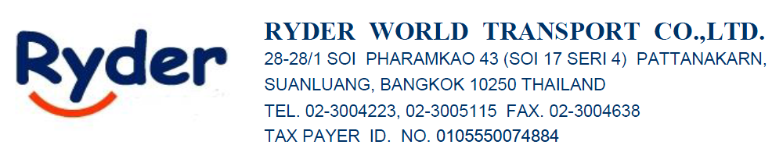
FCL FREIGHT RATE QUOTATION (EXPORT-DDP)
We are proudly present our air freight quotation for your kind consideration. Here below is the freight cost for your outbound delivery from Thailand to the destination ports of your requirement.

Port/Country | 20 | 40 | 40’HC | Frequency | Airlines | T/T
_{LCB-MEMPHIS} | _{$3,100} | _{$3,850} | _{$3,850} | _{WED/THU} | _{MSC/HAPAG} | _{35-45 DAY}

Local charges at Origin
-Insurance : DECLINED
-VGM : THB 850/CTNR
-THC : THB 4,390/ 40’HQ
-BL FEE : THB 1,500/ Set
-Surender FEE : THB 1,500/Set
-SEAL : THB 300/cont.
-Surrender B/L ( if ) : THB1,300 /Set
-Pick up : THB 7,500/40’HC
-Port Gate : THB 1,800/Entry
-Clearance (N) : THB 1,500/Entry
-Clearance (EPZ) : THB 1,800/Entry
-Clearance next CTNR : THB 800/Entry
-Customs Fee : THB 300/CTNR

Destination charges DDP
From Memphis, TN to TN 38118…
1. IMPORT SERVICE FEE : $85.00
2. ISF FILING CHARGE : $50.00/shpt
3. ISF BOND : $95.00 **This Item is free of charge, If cnee has "ANNUAL BOND" **
4. CUSTOM ENTRY SERVICE: $120.00/shpt
5. CUSTOM DUTY : AT COST ** 0.3464%MPF ( Min. $26.22) + 0.125%HMF **
6. CUSTOM BOND : $50.00 FOR FIRST US$7,000.00 OF BOND PREMIUM. THEREFORE, US$5.00 FOR EACH ADDITIONAL US$1,000.00 OF BOND PREMIUM. **This Item is free of charge, If cnee has "ANNUAL BOND" **
7.TRUCK FEE : $ 495.00/CTNR (Commercial Delivery Only)
8. FUEL SURCHARGE : 40%
9. RAIL DETENTION : $120.00/hr (1HR FREE After Arrival time)
10. WAIT TIME : $120.00/hr after 1 free hour (if required)
11. CHASSIS RENTAL FEE : $70.00/DAY ( Min. 2 days )
12. CHASSIS SPLIT : $150.00/CTNR
13. PRE-PULL FEE : $250.00/CTNR ( If required )
14. YARD STORAGE : $80.00/CTNR per Day (if required)
15. OTHER CHARGES : AT COST (EXAM, STORAGE, FDA, MESSENGER, TICKET ETC...)

We hope that the above quotation could meet your kind requirement. For any further information, please contact us. Thanks in advance for your support.

Best Regards,
Sirisak Srisuwan (Sam)
Sales

Ryder World Transport Co., Ltd.
28-28/1 Soi Pharamkao 43 (Soi 17 Seri 4)
Pattanakarn, Suanluang, Bangkok 10250 THAILAND
Tel: (662)300 4223, (662)300 5115 (Ext. 215)
Mobile: (66)65-625-4945
Fax: (662)300 5092
Website: www.ryder.co.th

